- (a−b)2=a2+b2−2ab
- (a+b)3=a3+b3+3ab(a+b)

1.)

import tensorflow as tf

with tf.name_scope("MyOperationGroup"):
with tf.name_scope("Scope_A"):
a=tf.subtract(5,4)
c=tf.multiply(a,a)

with tf.name_scope("Scope_B"):
d=tf.multiply(5,5)
with tf.name_scope("Scope_C"):
e=tf.multiply(4,4)
with tf.name_scope("Scope_D"):
f=tf.multiply(5,4)
g=tf.multiply(2,f)
h=tf.add(d,e)
i=tf.add(h,g)
with tf.Session( ) as sess:
writer=tf.summary.FileWriter("/tmp/tboard/output4",sees.graph)
print(sess.run(c))
print(sess.run(i))
writer.close( )

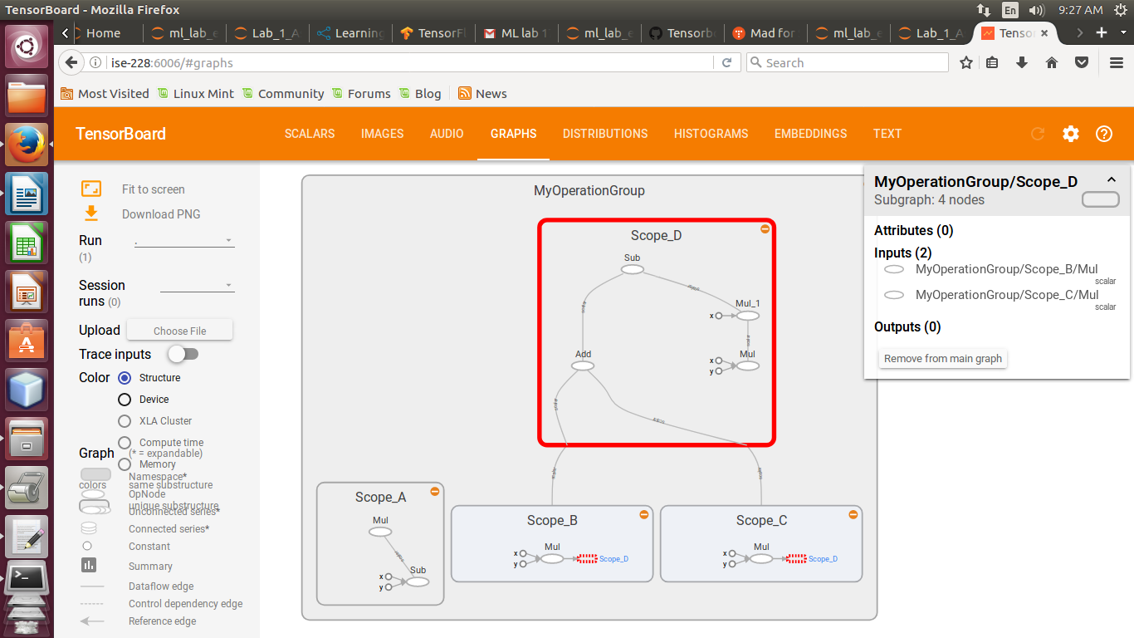

2.)
import tensorflow as tf

with tf.name_scope("CubicEquation"):
with tf.name_scope("Scope_A"):
a=tf.add(2,1,name="Add_the_numbers")
b=tf.multiply(a,a,name="Multiply_the_numbers")
c=tf.multiply(b,a,name="Multiply_again_to_get_cube")
with tf.name_scope("Scope_B"):
d=tf.multiply(2,2,name="Multiply_the_number")
e=tf.multiply(2,d,name="Multiply_again_to_get_cube")
with tf.name_scope("Scope_C"):
f=tf.multiply(1,1,name="Multiply_the_number")
g=tf.multiply(1,f,name="Multiply_again_to_get_cube")
with tf.name_scope("Scope_D"):
h=tf.add(2,1,name="Add_numbers")
i=tf.multiply(2,1,name="Multiply_numbers")
j=tf.multiply(h,i)
k=tf.multiply(3,j)
with tf.name_scope("Scope_E")
l=tf.add(e,g,name="Final_add_RHS")
m=tf.add(l,k,name="Final_add_RHS")
with tf.ession( ) as sess:
writer=tf.summary.FileWriter("/tmp/tboard/output6",sess.graph)
print(sess.run(c))
print(sess.run(m))
writer.close( )

